Site Purpose

The overall goal of the website is to promote and provide information about the specialized services that The Temple Inn & Suite Hotel Chain offers to meet the needs of temple patrons who come to serve in the temple or who participate in events such as sealings, weddings, receptions, and youth trips. The website reflects the Church culture and is designed to support a temple oriented theme as well as the concept of being a haven of comfort and accessibility.

Target Audience

The main Target audience of the website is members of the Church of Jesus Christ of Latter Day Saints that are planning in visiting the temple and need a place to stay and rest, groups of young men and women that plan temple trips to participate in Baptisms, wards that have temple trips and need a place to rest and stay, it is also focus on people that live far away from the temple and are going to have their own ordinances in the temple such sealings or weddings. Couples who want to have a reception after their sealing.

Site Map

HOME PAGE

TEMPLE PAGE

RESERVATION PAGE

SERVICES PAGE

THANK YOU PAGE

CONFIRMATION PAGE

.

Color Scheme

|  |  |  |  |
| --- | --- | --- | --- |
| DEEP SPACE SPARKLE  #476A6F | GREEN SHEEN  #7EB09B | PALE PINK  #F7DAD9 | SAGE  #C5C9A4 |
|  |  |  |  |

Typography

|  |  |  |  |  |
| --- | --- | --- | --- | --- |
| OBJECT / ITEM | FONT FAMILY | SIZE | COLOR | SAMPLE |
| SITE HEADER | Cinzel | 40px | #C5C9A4 | Sample |
| PRIMARY NAVIGATION | EB Garamond | 30px | #7EB09B | Sample |
| FOOTER NAVIGATION | Cinzel | 20px | #C5C9A4 | Sample |
| HEADING (h1) | Cinzel | 30px | #476A6F | Sample |
| HEADING (h2) | Cinzel | 25px | #476A6F | Sample |
| HEADING (h3) | Cinzel | 20px | #476A6F | Sample |
| PARAGRAPH (p) | EB Garamond | 16px | #F7DAD9 | Sample |

Wireframe Sketches

# **Monitor View**

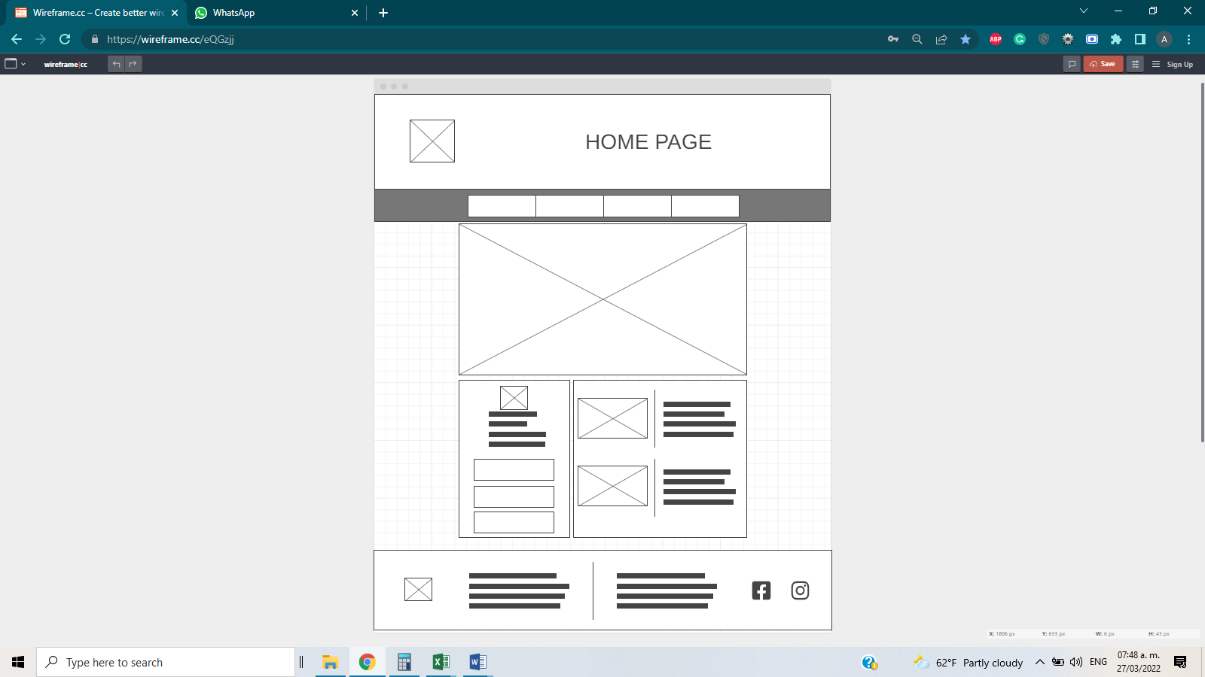

# 

# **Tablet View Phone View**

